SCHOOL OF COMPUTER SCIENCE AND ARTIFICIAL INTELLIGENCE |  |  |  |  | DEPARTMENT OF COMPUTER SCIENCE ENGINEERING
Program Name: B. Tech |  |  |  | Assignment Type: Lab |  |  | Academic Year:2025-2026
Course Coordinator Name |  |  |  | Venkataramana Veeramsetty
Instructor(s)Name |  |  |  | 1. Dr. Mohammed Ali Shaik  2. Dr. T Sampath Kumar  3. Mr. S Naresh Kumar  4. Dr. V. Rajesh  5. Dr. Brij Kishore  6. Dr Pramoda Patro  7. Dr. Venkataramana  8. Dr. Ravi Chander  9. Dr. Jagjeeth Singh
Course Code |  |  | 24CS002PC215 | Course Title |  | AI Assisted Coding
Year/Sem |  |  | II/I | Regulation |  | R24
Date and Day  of Assignment |  |  | 06-08-2025 | Time(s)
Duration |  |  | 2 Hours | Applicable to  Batches
AssignmentNumber:6.5(Present assignment number)/24(Total number of assignments)
 | Q.No. | Question |  |  |  |  |  | Expected Time  to complete
 | 1 | Lab 6: AI-Based Code Completion: Working with suggestions for classes, loops, conditionals  Lab Assignment 1: Intelligent Code Completion for Object-Oriented Programming  Objective: To explore AI-powered code assistants for writing Python classes, constructors, and methods through intelligent suggestions.  Suppose that you are hired as an intern at a tech company that develops inventory management systems. Your manager asks you to create a Product class and a Warehouse class with some basic methods. You have decided to use AI-powered code suggestions to help speed up development and reduce syntax errors.  Tasks to be completed are as below  1. Setup AI Coding Tool:  - Install and configure GitHub Copilot or Kite with VS Code or JetBrains IDE.  - Enable real-time code suggestions.  2. Class Design Using AI Assistance:  - Begin defining a Product class with attributes: name, price, quantity.  - Use the AI suggestion feature to automatically complete the __init__ () method.  - Add a method calculate value () to return price * quantity.  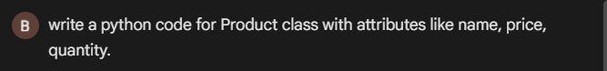  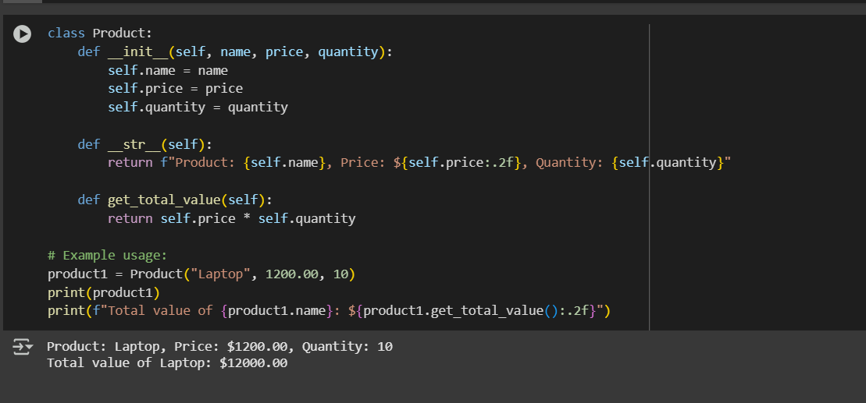  3. Create Another Class:  - Define a Warehouse class with a list of Product objects.  - Use code completion to help implement:  - A method to add a product.  - A method to display the most valuable product.  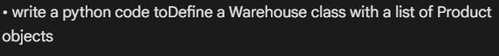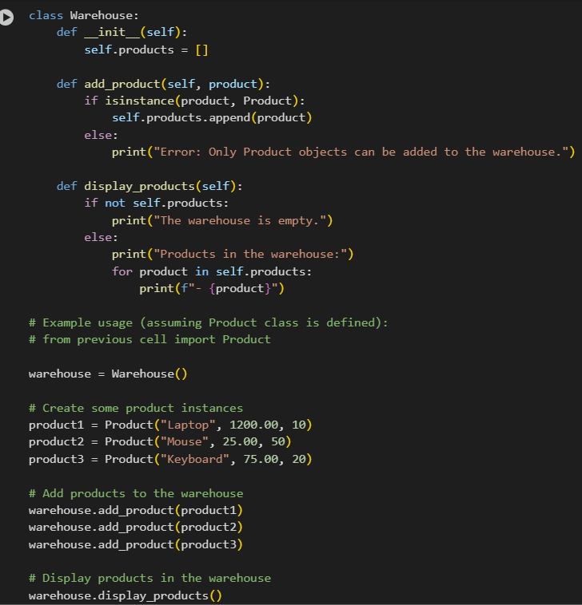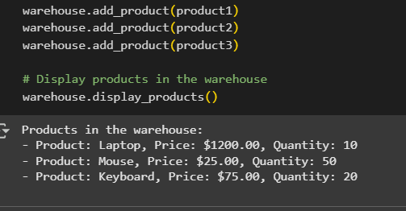  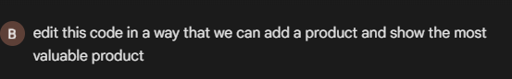  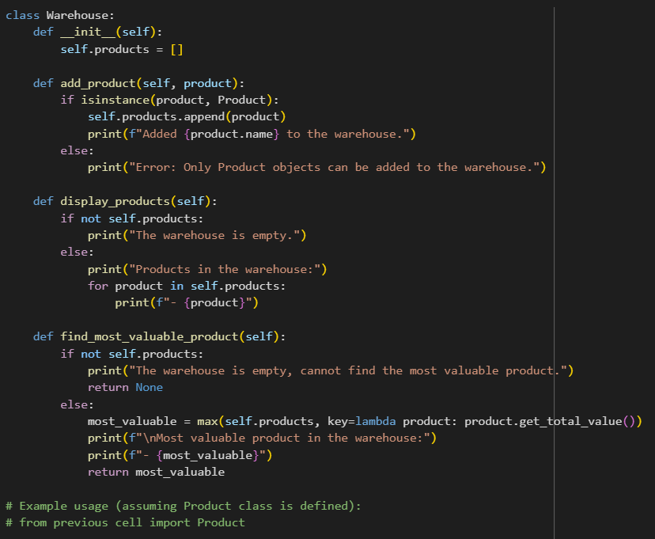  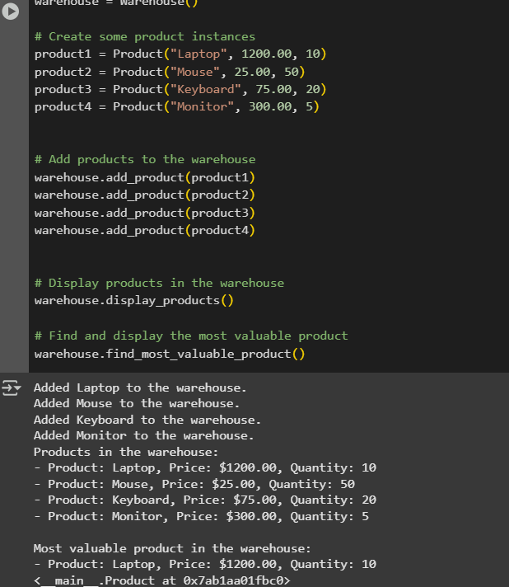  4. Reflection:  - Identify how much of the code was completed by AI and what manual edits were needed.  Code completed by AI: I generated the initial Product class code, added the get_total_value method to the Product class, and generated the Warehouse class code including the add_product, display_products, and find_most_valuable_product methods. All the example usage code for creating instances and calling methods was also generated by me.  Manual edits: It appears that you accepted the code I generated in each step without making any manual edits to the code within the cells themselves. The manual steps involved accepting the generated code and executing the cells.  In summary, I provided the code for both the Product and Warehouse classes and their methods based on your requests, and you executed the code in the notebook.  - Comment on the relevance and accuracy of AI suggestions.  Reflecting on our interaction, I believe the AI suggestions were relevant and accurate in addressing your requests.  Relevance: Each suggestion and code generation step directly addressed your prompts, such as creating the Product class, adding the get_total_value method, and defining the Warehouse class with its functionalities. The suggestions for next steps were also relevant to expanding the object-oriented model we were building.  Accuracy: The Python code generated was syntactically correct and functionally accurate for the tasks requested. The methods in both the Product and Warehouse classes performed their intended operations correctly, as demonstrated by the execution outputs in the notebook.  Overall, the suggestions and code provided were relevant to the task of building a simple inventory management system using Python classes and accurately implemented the requested features.  Requirements:  - VS Code with GitHub Copilot or Cursor API and/or Google Colab with Gemini  Deliverables:  - Python script with both classes and comments on AI-generated suggestions.  - Short report (1 page) summarizing your experience with AI code completion.  . |  |  |  |  |  | 15.08.2025 EOD

